# Weekly Report – 07.05.2018

* PCB Design: 133mm board, isolations
* Connector Selection: <https://github.com/mesutto/IMMD/blob/master/Project/3501/Furkan/Board%20Connectors/Connectors.xlsx>
* Double Pulse Test Circuit & Inductor
* BAP Rapor: GaN ve PCB: <https://drive.google.com/drive/folders/1W0h1dTY9sZ1uK-pKI5kdxf7MX8ONeB0H>

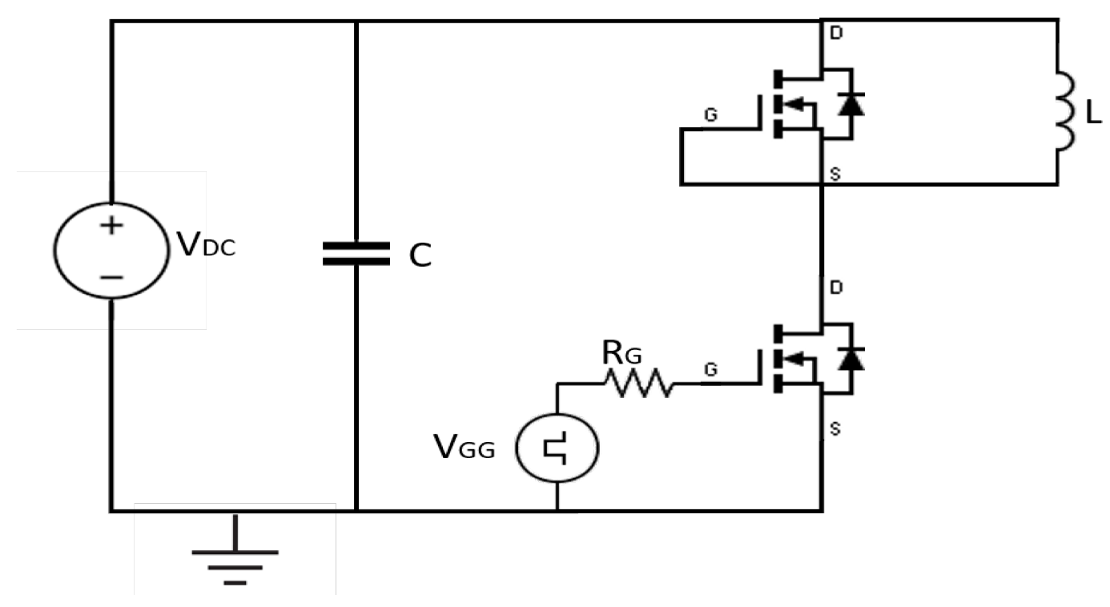

Figure : Double Pulse Test Circuit

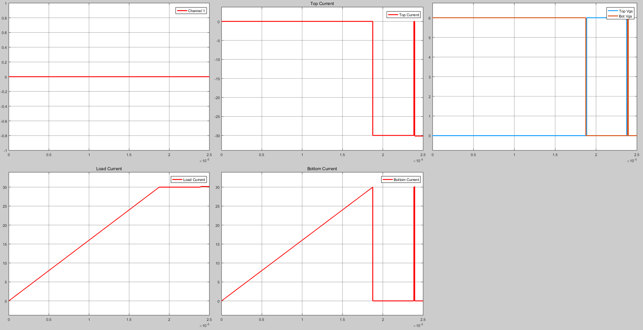

Figure : Waveforms

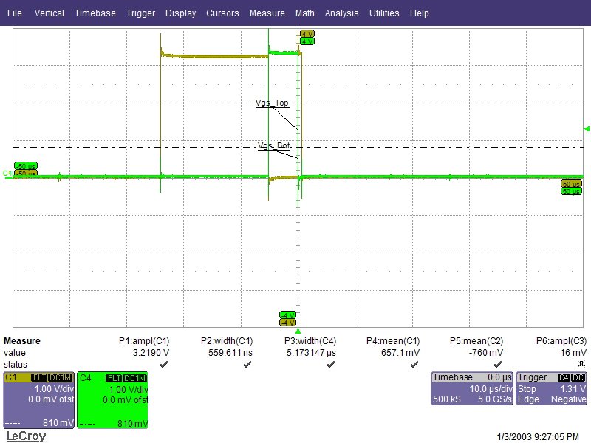

Figure : Scope waveforms

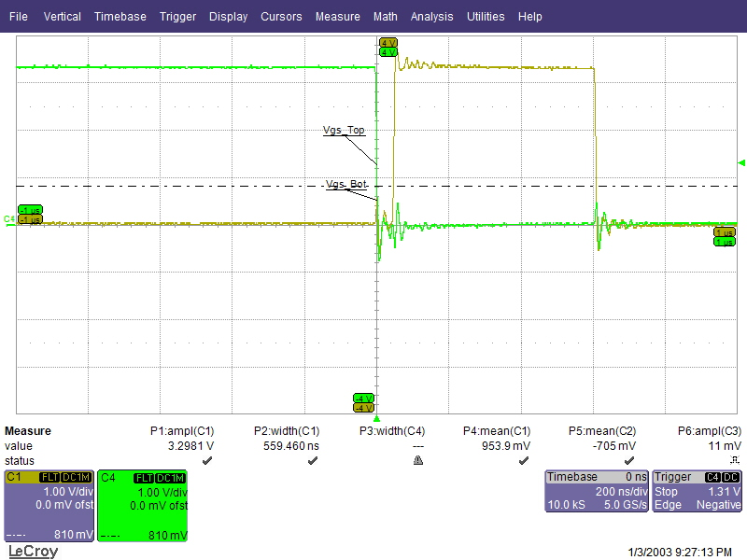

Figure : Dead Time